FACULTY EVALUATION
Programme Name: Social Entrepreneurship Development Program (SEDP)- Start Tanzania Module 3 (2nd February - 6th February 2026)
Session: Business (social enterprise) planning
Faculty Name: Benard Chege
No. of Respondents: 18
No. of Participants: 18
Evaluation Parameter | (%) Individual Score | (%) Programme Average
Punctuality (Commencement and Completion of Sessions) | 96 | 95
How well do you understand the core concepts presented? | 79 | 87
Rate your confidence in applying the new skills learnt | 84 | 88
Degree of Faculty preparedness for the sessions | 90 | 91
Content and methodology of the program | 88 | 91
Quality of class and group discussions | 83 | 89
The information presented in the course is relevant to my work (ministry) | 88 | 91
Average scores | 87 | 90

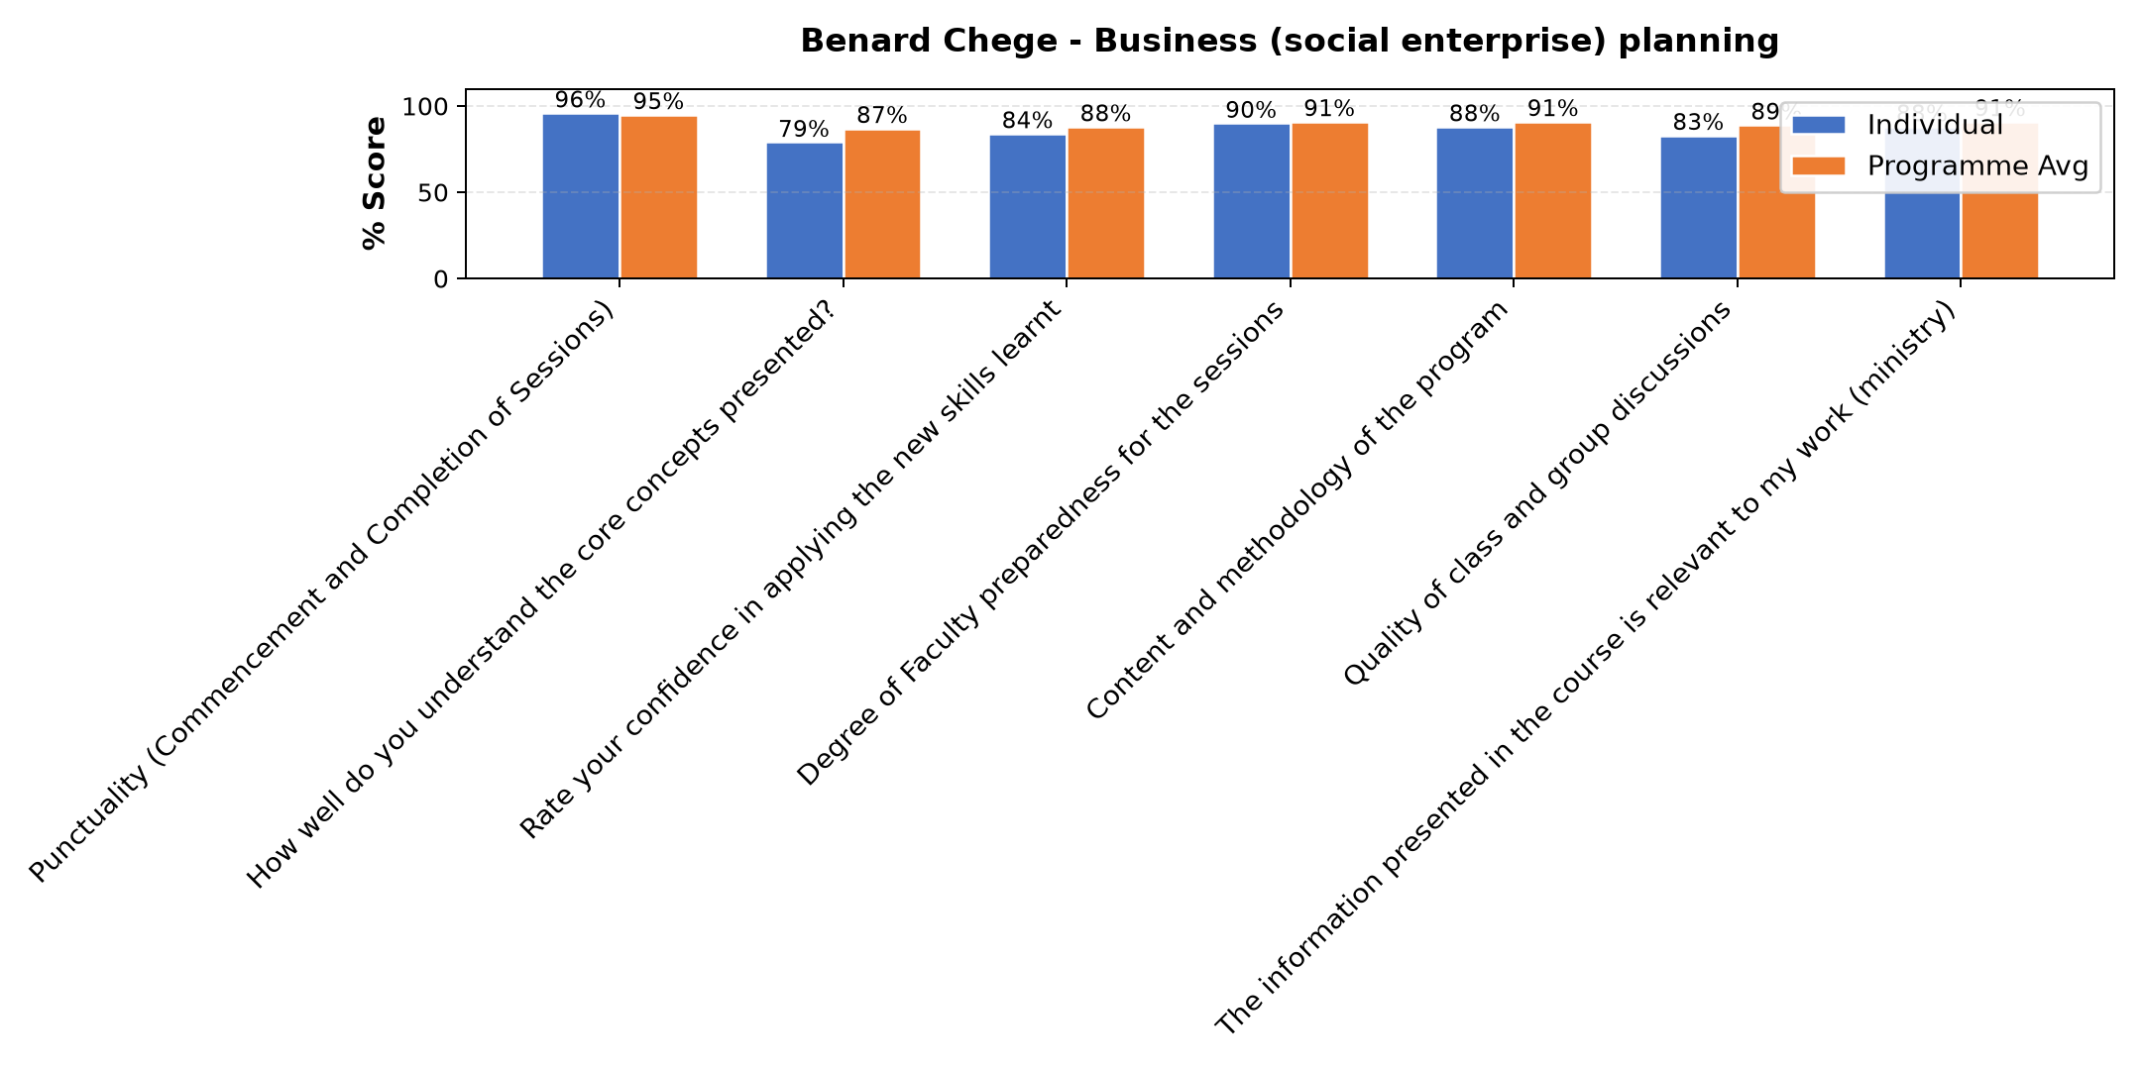

Comments & Feedback
No comments recorded.
SUBMITTED THROUGH:
SBS Evaluation Automation System

